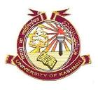
School of Law
University of Kashmir
(NAAC Accredited Grade “A+”)

Dated: 27/07/2019
Notice

Students of BALLB 10th semester are informed that in view of administrative delay in providing authorization for Legal Literacy programme the 1st paper (Cr.PC) scheduled on 31st July is postponed as students who are appearing in the examination are presently deputed for Legal Literacy Programme. New date for the 1st paper will be notified separately. Date sheet for other papers will be followed as per schedule already notified.

Sd/-
Prof. Mohammad Hussain,
Head & Dean

