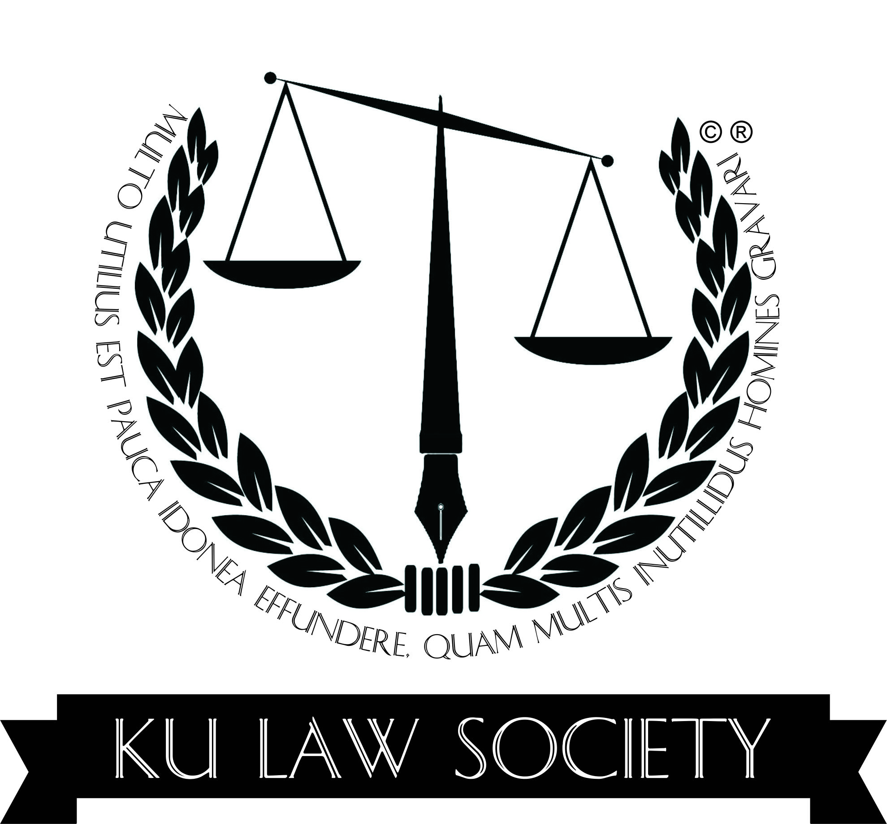

LAW SOCIETY
School of Law, University of Kashmir
Achievements of the Year 2018

S. No. | Event Type | Date | Venue | Guests Invited | Topic
01 | Refresher Course | 08-01-2018  To  13-01-2018 | Conference Hall  Department of Law  University of Kashmir | Mr. Zaffar Ahmad Shah (Sr. Advocate J&K High Court)  Prof Musadiq Amin Sahaf (Dean Academic Affairs, University of Kashmir) Prof. Zaffer Ahmad Reshi (Dean Research, University of Kashmir)  Prof. Mahmood Ahmad Khan  (Former Head and Dean Faculty of Education, University of Kashmir)  Dr. Manzoor Ahmad  (Chief Coordinator, DIQA, University of Kashmir) Prof. Farooq Ahmad Mir (Former Head and Dean, School of Law , University of Kashmir),  Prof. Mohammad Ayoub (Former Head and Dean, School of Law, University of Kashmir)  Mr. Abdul Rashid Malik (Director, State Judicial Academy, J&K)  Prof. V.K. Ahuja (In-Charge Law Centre-II, University of Delhi) | One-Week Refresher Course for LL.M Scholars.
02 | Valedictory Ceremony | 13-01-2018 | Gandhi Bawan  University of Kashmir | Prof Khursheed Andrabi  (Hon’ble Vice Chancellor, University of Kashmir)  Prof Mehraj ud Din  (Hon’ble Vice Chancellor, Central University of Kashmir)  Prof.Khursheed Ahmed Butt  (Hon’ble Registrar, University of Kashmir)  Prof Dr.Mohammad Hussain  (Head and Dean, School of Law University of Kashmir)  Prof. Farooq Ahmad Mir (Former Head and Dean, School of Law )  Prof. Mohammad Ayoub (Former Head and Dean, School of Law) | One-Week Refresher Course for LL.M Scholars.
03 | Plantation Drive | 24-03-2018 | Zakura Campus  University of Kashmir | Prof.Khursheed Ahmed Butt  (Hon’ble Registrar, University of Kashmir)  Prof Dr.Mohammad Hussain  (Head and Dean, School of Law University of Kashmir)  Prof. Ghulam Mohiudin Bhat  (Director Zakura Campus) | More Trees for Safe Environment.
04 | Two Day Workshop on  Negotiation & Mediation | 23-04-2018  -  24-04-2018 | Conference Hall  School of Law | Prof Khursheed Andrabi  (Hon’ble Vice Chancellor, University of Kashmir)  Prof.Khursheed Ahmed Butt  (Hon’ble Registrar, University of Kashmir)  Prof Dr.Mohammad Hussain  (Head and Dean, School of Law University of Kashmir)  Mr. Jonathan Rodrigues  (Founder PACT) | Peacekeeping and Conflict Resolution
05 | Legal Quiz Competition | 04-07-2018 | Conference Hall  School of Law | Prof Dr.Mohammad Hussain  (Head and Dean, School of Law University of Kashmir)  Dr. Fareed A. Rafiqi  (Chairman Law Society) | Legal Knowledge.
06 | National Moot- Court Competition | 08-10-2018  to  10-10-2018 | Gandhi Bhawan and School of Law | Prof. Talat Ahmad  (Honble Vice Chancellor, University of Kashmir)  Justice Hasnain Masoodi  (Former Judge J&K High Court)  Justice B.A. Kirmani  (Former Judge J&K High Court)  Prof. Nilofer Khan  (Registrar Kashmir University)  Prof. Anand Paliwal  ( Dean, College of Law, Mohanlal Sukhadia University, Udaipur, Rajasthan)  Prof Dr.Mohammad Hussain  (Head and Dean, School of Law University of Kashmir)  Dr. Fareed A. Rafiqi  (Chairman Law Society) | Advocacy and Lawyering Skills.
07 | Counseling Program | 05-11-2018 | Conference Hall | Prof Dr.Mohammad Hussain  (Head and Dean, School of Law University of Kashmir)  Dr. S.A.Bhat  (Teacher In-charge Law Society)  Dr. Muhammad Yasin  (Course Coordinator) | Guidance and Counseling Program for newly enrolled law students.
08 | Cancer Awareness | 15-11-2018 | Examination Hall  School of Law | Prof Dr. Mohammad Hussain  (Head and Dean, School of Law University of Kashmir)  Dr. Fareed A. Rafiqi  (Chairman Law Society)  Tariq Abdullah  (Incharge NSS Unit KU)  Dr. Nazir Ahmad Khan  (Prof. Oncology SKIMS)  Prof. G.M. Untoo  (Executive Member, Cancer Society of Kashmir)  Dr. Lone M. Maqbool  (Prof. Radio -oncology SKIMS) | Cancer Prevention and Early Detection Program.

